SECTION 12765 - TELESCOPING PLATFORM & GALLERY 3 CHAIR SYSTEM SPECIFICATIONS

PART 1 GENERAL

1.01 SUMMARY

A. Section Includes: Telescoping Platform Seating includes, either manually or electrically operated systems of multiple-tiered seating rows comprising of seat, deck components, understructure that permits closing without requiring dismantling, into a nested configuration for storing or for moving purposes.

ED NOTE: REVISE BELOW TO SUIT PROJECT

1. Typical applications include the following:
a. Wall Attached Telescoping Platform Seats.
b. Recessed Telescoping Platform Seats.
- Floor-Attached (Freestanding) Telescoping Platform Seats.
- Portable/Movable Telescoping Platform Seats.

ED NOTE: REVISE BELOW TO SUIT PROJECT

2. Special applications include the following:
a.
b.
c.

B. Related Sections:
- Division 9 finishes sections for adequate floor & wall construction for operation of Telescoping Platform Seats. Flooring shall be level and rear wall plumb within 1/8” [3mm] in 8’-0 [2438mm]. Maximum Platform force on the floor, of a 19’6” [5944] section, shall be a static point load of less than 300 psi [2.07 Mpa]

2. Division 16 Electrical sections for electrical wiring and connections for electrically operated Telescoping Platform Seats.

C. Alternates: This section specifies alternates for Telescoping Platform Seat products. Refer to Part 2 products for alternate products, and to Division 1 Alternates sections and other bid documents, if any, for alternate requirements.

1.02 REFERENCES

A. National Fire Protection Association 102-2006
B. ICC 300-2002
C. American Welding society (AWS):
1. AWS D1.1 Structural Welding Code - Steel.
2. AWS D1.3 Structural Welding Code - Sheet Steel.
D. American Institute of Steel Construction (AISC):
1. AISC - Design of Hot Rolled Steel Structural Members.

E. American National Standards Institute (ANSI).

F. American Iron & Steel Institute (AISI):
1. AISI - Design Cold Formed Steel Structural Members.

G. Aluminum Association (AA):
1. AA - Aluminum Structures, Construction Manual Series.

H. American Society for Testing Materials (ASTM):
1. ASTM - Standard Specification for Properties of Materials.

I. National Forest Products Association (NFoPA):
1. NFOPA - National Design Specification for Wood Construction.

J. Southern Pine Inspection Bureau (SPIB):
1. SPIB - Standard Grading Rules for Southern Pine.

K. National Bureau of Standards/Products Standard (NBS/PS):
1. PS1 - Construction and Industrial Plywood.

L. Americans with Disability Act (ADA)
1. ADA - Standards for Accessible Design.

1.03 MANUFACTURER'S SYSTEM ENGINEERING DESCRIPTION

A. Structural Performance: Engineer, fabricate and install telescopic Platform seating systems to the following structural loads without exceeding allowable design working stresses of materials involved, including anchors and connections. Apply each load to produce maximum stress in each respective component of each Platform seat unit.

1. Design Loads: Comply with NFPA 102, 2002 Edition, Chapter 5 for design loads, as well as ICC 300 – 2002.

B. Manufacturer's System Design Criteria:
1. Platform seat assembly; Design to support and resist, in addition to it’s own weight, the following forces:
a. Live load of 120 lbs per linear foot [1751 N/m] on seats and decking
b. Uniformly distributed live load of not less than 100 lbs per sq. ft. [4788 N/m²] of gross horizontal projection.
c. Parallel sway load of 24 lbs. per linear foot [350 N/m] of row.
d. Perpendicular sway load of 10 lbs. per linear foot [146 N/m] of row.

2. Hand Railings, Posts and Supports: Engineered to withstand the following forces applied separately:
a. Concentrated load of 200 lbs. [890 N] applied at any point and in any direction.
b. Uniform load of 50 lbs. per foot [730 N/m] applied in any direction.

3. Guard Railings, Post and Supports: Engineered to withstand the following forces applied separately:
a. Concentrated load of 200 lbs. [890 N] applied at any point and in any direction along top rail.
b. Uniform load of 50 lbs. per foot [730 N/m] applied horizontally at top rail and a simultaneous uniform load of 100 lbs. per foot [1460 N/m] applied vertically downward.

4. Member Sizes and Connections: Design criteria (current edition) of the following shall be the basis for calculation of member sizes and connections:
a. AISC: Manual of Steel Construction
b. AISI: Specification for Design of Cold Formed Steel
Structural Members
c. AA: Specification for Aluminum Structures
- NFOPA: National Design Guide For Wood Construction.

C. Chairs

1. Seats:
- Shall be cantilevered, self-centering, automatic three-quarters lift with over center retracting feature for ease of row passage and janitorial access.
- Seat shall be tested and professionally certified to support and withstand an evenly distributed 440 lb [1957 N] static load without failure or irregularities that would impair usefulness.
- Self-lifting seat shall be tested and professionally certified through an independent testing laboratory to withstand 350,000 operating cycles without failure of seat mechanism or measurable component wear.
- Seat shall be tested and professionally certified to withstand 10,000 impacts of a 40 lb [178 N] sandbag dropped on the center of the seat from a height of 12"[305mm]. The rate of impacts shall be approximately 18 per minute.

- Backs:
- Back shall withstand an evenly distributed front or rear static load of 330 lbs [1468N].
- Back shall be tested and professionally certified to withstand, without failure, 10,000 swinging impacts each to the front and rear of the back by means of two opposing 40 lb. [18 Kg] sandbags. The sandbags shall be moved horizontally and equally for 10,000 cycles each at the distance of 12"[305mm] at a rate of 35 cycles per minute.

- Armrests shall be tested and professionally certified to withstand, without failure, a 200 lb [890 N] static load applied both perpendicular to and vertically down on the arm.

- Materials (Flammability) shall satisfy applicable test, codes, standards, or requirements as follows:
- Copolymer polypropylene shall have a burn rate of 1 inch [25 mm] per minute or less per ASTM 635.
- Upholstery materials shall meet requirements as set forth in the state of California Bureau of Home Furnishings Technical Bulletin 117.
- Fire-performance Characteristics of Seat Padding: Provide seating that complies with test method: California Technical Bulletin 117
- Cushioning and padding shall be self-extinguishing as defined in the requirements as set forth in the State of California Bureau of Home Furnishings Technical Bulletin 117.
ED. NOTE: SELECT THE FOLLOWING, AS REQUIRED. Full Scale Fire Performance Characteristics of Finished Chair: (REQUIRES INCLUSION OF CAL TB133 FIRE BARRIER) Provide seating that complies with test method: California Technical Bulletin 133 & British Standard Crib 5.

1.04 SUBMITTALS

A. Section Cross-Reference: Required submittals in accordance with "Conditions of the Contract" and Division 1 General Requirements sections of this "Project Manual."

B. Project Data: Manufacturer's product data for each system. Include the following:
1. Project list: Ten (10) seating projects of similar size, complexity and in service for at least five (5) years.
2. Deviations: List of deviations from these project specifications, if any.

C. Shop Drawings: Indicate Telescoping Platform Seat assembly layout. Show seat heights, row spacing and rise, aisle widths and locations, assembly dimensions, anchorage to supporting structure, material types and finishes.
1. Wiring Diagrams: Indicate electrical wiring and connections.
2. Graphics Layout Drawings: Indicate pattern of contrasting or matching seat colors

D. Samples: Seat materials and color finish as selected by Architect from manufacturers offered color finishes.

- Manufacturer Qualifications: Certification of insurance coverage and manufacturing experience of manufacturer.

F. Installer Qualifications: Installer qualifications indicating capability, experience, and manufacturer acceptance.

G. Engineer Qualifications: Certification by a professional engineer registered in the state of manufacturer that the equipment to be supplied meets or exceeds the design criteria of this specification.

H. Operating/Maintenance Manuals: Provide to Owner maintenance manuals. Demonstrate operating procedures, recommended maintenance and inspection program.

I. Warranty: Manufacturers standard warranty documents.

1.05 QUALITY ASSURANCE

ED NOTE: BELOW STANDARD MAY BE MORE STRINGENT THAN APPLICABLE BUILDING CODE REQUIREMENTS. COORDINATE WITH IBC, SBCCI, NFPA CODE REQUIREMENTS FOR TELESCOPIC SEATS.

A. Seating Layout: Comply with current NFPA 102 Standard for Assembly seating, Tents, and Membrane Structures, and specifically with Folding and Telescopic Seating, except where additional requirements are indicated or imposed by authorities having jurisdiction.

B. Welding Standards & Qualification: Comply with AWS D1.1 Structural Welding Code - Steel and AWS D1.3 Structural Welding Code - Sheet Steel.

C. Insurance Qualifications: Mandatory that each bidder submit with his bid an insurance certificate from the manufacturer evidencing the following insurance coverage:

1. Workers Compensation - including Employers Liability with the following limits:
$500,000.00 (US) Each Accident
$500,000.00 (US) Disease - Policy Limit
$500,000.00 (US) Disease - Each Employee

2. Commercial General Liability - including premises/ operations, independent contractors and products completed operations liability. Limits of liability shall not be less than $5,000,000.00 (US).

D. Manufacturer Qualifications: Manufacturer who has a minimum of twenty years of experience manufacturing telescoping Platform seats.

E. Installer Qualifications: Engage experienced Installer who has specialized in installation of telescoping Platform seat types similar to types required for this project and who is acceptable to, or certified by, telescoping Platform seat manufacturer.

F. Engineer Qualifications: Engage licensed professional engineer experienced in providing engineering services of the kind indicated that have resulted in the successful installation of telescoping Platforms similar in material, design, fabrication, and extent to those types indicated for this project.

1.06 DELIVERY, STORAGE AND HANDLING

A. Deliver telescopic Platforms in manufacturers packaging clearly labeled with manufacturer name and content.

B. Handle seating equipment in a manner to prevent damage.

C. Deliver the seating at a scheduled time for installation that will not interfere with other trades operating in the building.

1.07 PROJECT CONDITIONS

A. Field Measurements: Coordinate actual dimensions of construction affecting telescoping bleachers installation by accurate field measurements before fabrication. Show recorded measurements on final shop drawings. Coordinate field measurements and fabrication schedule with construction progress to avoid delay of Work.

1.08 WARRANTY

A. Manufacturer's Product Warranty: Submit manufacturer's standard warranty form for telescoping Platforms. This warranty is in addition to, and not a limitation of other rights Owner may have under Contract Documents.
1. Warranty Period: Five years from Date of Acceptance.
2. Beneficiary: Issue warranty in legal name of project Owner.
3. Warranty Acceptance: Owner is sole authority that will determine acceptance of warranty documents.

1.09 MAINTENANCE AND OPERATION

A. Instructions: Both operation and maintenance shall be transmitted to the Owner by the manufacturer of the seating or his representative.

B. Service: Maintenance and operation of the seating system shall be the responsibility of the Owner or his duly authorized representative, and shall include the following:
1. Operation of the Seating System shall be supervised by responsible personnel who will assure that the operation is in accordance with the manufacturer's instructions.
2. Only attachments specifically approved by the manufacturer for the specific installation shall be attached to the seating.
3. An annual inspection and required maintenance of each seating system shall be performed to assure safe conditions. At least biannually the inspection shall be performed by a professional engineer or factory qualified service personnel.

PART 2 - PRODUCTS

ED NOTE: MANUFACTURER DOES NOT RECOMMEND THE USE OF PHRASES “OR EQUAL” / “OR APPROVED EQUAL” BECAUSE OF DIFFERING INTERPRETATIONS BETWEEN CONTRACTING PARTIES. CONSIDER UTILIZING “ALTERNATE” METHOD OF SPECIFYING PRODUCTS FOR LISTING ALTERNATE MANUFACTURERS AND PRODUCTS. (SEE ARTICLE 2.02 HERE IN).

2.01 MANUFACTURERS

A. Manufacturer: Hussey Seating Company, U.S.A.
1. Address: North Berwick, Maine, 03906
2. Telephone: (207) 676-2271; Fax: (207) 676-9690

ED NOTE: ADD BELOW SELECTIONS FROM MANUFACTURER’S LITERATURE AND COORDINATE SELECTIONS WITH DRAWINGS.

3. Product: Hussey Telescopic Platform Seat System

  - MAXAM-Plus Series Telescopic Platform Seats, adjustable row spacing in either 30 inches [762], 32 inches [813] or 33 inches [838].
  - MAXAM-Plus Series Telescopic Platform Seats, adjustable rise SELECT Rise Spacing: 9 5/8” [244], 11 5/8” [295] or 16” [406] or Custom Rise 9 5/8” [244] min. – 16” [406] max. row rise at any dimensional increments. Variable/ Combination Rise solutions also available upon request. Consult your Hussey Representative for engineering details.
d. Aisle Type: SELECT: foot level aisles, front steps, and intermediate aisle steps.
e. Seat Type: SELECT: Wood bench with or without folding polymer backrests, CourtSide XC10 or CourtSide XCS12, with or without CourtSide XT (Spacer) , CourtSide CB (Contoured Backrest), or Metro chairs
- CourtSide Seat color finish: SELECT: manufacturers 15 standard colors.
- Gallery Chairs color finish: SELECT: manufacturers 19 standard colors.
- (See Personalization and Creativity under Accessories section)
f. Rail Type: SELECT: Self Storing or removable end rails, front railings, rear rails, aisle hand rails
g. Operation: SELECT: electrical power or manual
1) Electrical Power System: SELECT: Integral power with pendant control, motion monitor, limit switches, portable tractor
- Transport System (Portable Sections Only): (SELECT: integral dollies, portable dollies)
- Platform Type: (SELECT: wall attached, portable, freestanding, recessed, reverse-fold)
- Chair Operation: Manual or Manual w/ Gas Assist

ED NOTE: SELECT CHAIR OPERATION TYPE BELOW.

- Manual Operation: Chairs shall be ganged in group(s) of one to four, manually raised and lowered with foot-assist. Armrests shall be manually flipped-down during raising of chairs.
- Lift-Assist: Chairs shall be ganged in group(s) of one to fourteen, manually raised and lowered as one unit with gas strut assist to offset weight. Lift-Assist operation will require unlocking of chair gangs with ergonomic t-handle tool at aisle location.
- Auto-Fold: Chairs shall be ganged in group(s) of one to fourteen, manually raised as one unit with gas strut assist to offset weight. Auto-Fold operation will allow seating rows 2 and above to be unlocked and lowered via mechanism below the deck surface. This mechanism is activated during the closure of the bleacher. Row 1 will have Lift-Assist operation requiring the unlocking of chair gangs with the ergonomic t-handle tool at aisle location.

i. Gallery Chair Dimensions

i. Seat up envelope: 10 1/4” [260mm]

ii. Seat down envelope: 23 15/16” [608mm]

iii. Seat height: 18” [457mm]

iv. Armrest height: 26 1/8” [663mm]

v. Back height: 32” [813mm]

j. Chair Construction: (SELECT: fully enveloped upholstered back & seat)

4. Product Description/Criteria:
a. Bank Length:
b. Aisle Widths:
c. Number of Tiers:
d. Row Spacing(s):
e. Row Rise:
f. Open Dimension:
g. Closed Dimension:
h. Overall Unit Height:
i. Net Capacity: per seat
18” [457] for CourtSide Collection
18” to 21 1/4” [460-540] for Gallery Chairs

5. Miscellaneous Product Accessories: SELECT: operating handles, front panels, end panels, rear panels, scorer's table, top seat filler, seat numbers, row letters, end curtains, manual aisle closure, rubber gap closures, aluminum gap closures, program supports, floor pintels, aisle lights.
6. Special Applications: SELECT: tapered sections, truncated units, high humidity finish, cross aisles, portable access stairs, programming supports, extended rear deck filler, rear wall column cutouts.
- Handicap Seating Provisions: Provide first tier handicap cutouts per requirements of (ADA) Americans with Disability Act located as indicated.

B. Other Acceptable Manufacturers: Will be considered if in compliance with these specifications. Deviations must be submitted with bid in order that a fair and proper evaluation be made. Those bidders not submitting a list of deviations will be presumed to have bid as specified.

NOTE: COORDINATE BELOW ARTICLE WITH RELATED DIVISION 1 SECTION FOR ALTERNATES, AND BID DOCUMENTS AND BID FORMS FOR BID TYPE PROJECTS

2.02 ALTERNATES
A. Base Bid:
1. Base Bid Product:
2. Base Bid Product Accessories:

B. Alternate No. : In lieu of providing base bid product, provide the following:
1. Alternate Product:
2. Alternate Product Accessories:

C. Alternate No. : In lieu of providing base bid product, provide the following:
1. Alternate Product:
2. Alternate Product Accessories:
ED NOTE: BELOW ARTICLE FOR GENERIC / REFERENCE SPECIFICATION.

2.03 MATERIALS

A. Lumber: ANSI/Voluntary Product 20, B & B Southern Pine

B. Plywood: ANSI/Voluntary Product PS1, APA A-C Exterior Grade.

C. Structural Steel Shapes, Plates and Bars: ASTM A 36.

D. Uncoated Steel Strip (Non-Structural Components): ASTM A1011, Commercial Quality, Hot-Rolled Strip.

E. Uncoated Steel Strip (Structural Components): ASTM A1011 Grade 33, 40, 45, or 50, Structural Quality, Hot-Rolled Strip.

F. Galvanized Steel Strip: ASTM A653 Grade 40, zinc coated by the hot-dip process, structural quality.

G. Structural Tubing: ASTM A500 Grade B, cold-formed.

H. Polyethylene Plastic: ASTM D 1248, Type III, Class B; molded, color-pigmented, textured, impact-resistant, structural formulation; in color indicated or, if not otherwise indicated, as selected by Architect from manufacturer's standard colors.

I. Fasteners: Vibration-proof, of size and material standard with manufacturer.

2.04 UNDERSTRUCTURE FABRICATION

A. Frame System:
      - Wheels: Not less than four 5" [127] diameter by 1 1/4" [32] with non-marring soft rubber face to protect wood and synthetic floor surfaces, with molded-in sintered iron oil impregnated bushings to fit 3/8" [10] diameter axles secured with E-type snap rings.
      - Lower Track: Continuous Positive Interglide System interlocks each adjacent CPI unit using an integral, continuous, anti-drift feature and through-bolted guide at front to prevent separation and misalignment. Each CPI unit shall contain a Low Profile Posi-Lock LX to lock each row in open position and allow unlocking automatically. Provide adjustable stops to allow field adjustment of row spacings.
      - Slant Columns: High tensile steel, tubular shape.
      - Sway Bracing: High tensile steel members through-bolted to columns.
      - Deck Stabilizer: High tensile steel member through-bolted to nose and riser at three locations per section. Interlocks with adjacent stabilizer on upper tier using low-friction nylon roller to prevent separation and misalignment. Incorporates multiple stops to allow field adjustment of row spacings.
      - Deck Support: Securely captures decking for entire length of section

B. Deck System:
1. Section Lengths: Each bank shall contain sections not to exceed 19’ 5” (5944) in length with a minimum of two supporting frames per row, each section.
- Nosing and Rear Riser: Continuous roll formed galvanized steel members.
- Attachment: Through-Bolted fore/aft to deck stabilizers, and frame cantilevers.
- Deck End Overhang: Not to exceed frame support by more than 5'-7 1/2" [1715].

ED. NOTE: SELECT DECKING OPTION

- Extruded Aluminum Decking: 5/8" [16], 6063-T6 grade, clear anodized
oriented from front of deck to rear of deck (nose beam to riser beam). Adjacent pieces shall be locked together with snap interlocking feature from front to rear of deck. Longest unsupported span: MAXAM Plus, 28 ½” [724].

- Aluma-Deck: Shall be a aluminum overlay panel fabricated with a skid-resistant textured top surface of 100% moisture barrier bonded to a plywood substrate with an exterior glue. Panel thickness shall be 3/4” [19] with top aluminum surface.

- Poly Deck: Shall be a high-density polyethylene overlay panel fabricated with a skid-resistant textured top surface of 100% moisture barrier bonded to a plywood substrate with an exterior glue. Panel thickness shall be 3/4” [19] with top polyethylene surface colored weathered gray.

- Classic Wood Deck: 3/4" [19], AC grade clear-top-coated tongue and groove Southern Yellow Pine; or BC grade polyethylene-top-coated tongue and groove Douglas Fir plywood; both of interior type with exterior glue, 5-ply, all plies with plugged cross-bands, produced in accordance with National Bureau of Standards PS-1-97. Plywood shall be cut and installed with top, center and bottom ply grain-oriented from front of deck to rear of deck (nose beam to riser beam). Adjacent pieces shall be locked together with tongue and groove joint from front to rear of deck. Longest unsupported span: MAXAM Plus, 28 ½” [724].

- Carpeted Decks: Provide at decks and steps double tufted, anti-static, solid and crush resistant 100% polypropylene pile with high-density foam backing carpet. Mount to Classic Wood deck as substrate. Carpet color to be of manufacturer's standard selection.

2.05 SEATING FABRICATION

ED NOTE: COORDINATE BELOW PARAGRAPHS WITH SELECTION MADE UNDER PRODUCT DESCRIPTION.

A. Plastic Seat System – Courtside Collection XC10 (10”) or XCS12 (12”):

Hussey Courtside Collection Series embodies the latest leading edge innovations in linear telescopic seating modules. Courtside seats utilize a harmonious blend of advanced ergonomic principals, architecturally appealing design, safety, value and performance.
- Seat Modules: 18" [457] long assembled, gas assisted injection-molded, high density, 100% recyclable HDPE (high density polyethylene) modules in monochromatic colors providing, dual textured scuff resistant 10" [254] or 12” [305] wide seat surface with ½” [13] minimum interlock on seat and face. Unit structural tested to 600 lbs occupant load.

Courtside XC10 Seat Module
- XC10 – 10” Comfort Profile
- 10” wide continuous comfort curve style bench seat
- Ergonomically contoured forward “waterfall” edge for enhanced spectator comfort and minimization of sensitive pressure point area, regardless of leg positioning.
- Fore & Aft contoured seat surface for uniform support and minimize high pressure points under the buttocks.
- Seat height ranges from deck to t/o seat range from 16-1/8” to 18-1/8”
- 21-1/2” clear foot space area, regardless of leg positioning.
- Integrally molded end caps at aisle end locations for clean finished appearance.
- Optional: Custom color graphic logo design application for end cap insert. (See Personalization and Creativity under Accessories section)
- Integrally molded recess pockets to accept seat number and row letters.
- Integrally molded rear closure panel at back of seat to allow for “continuous clean sweep” of debris at deck level and minimized visibility of structural ribbing.
- Seat Attachment: Each plastic seat module shall be securely anchored by a 12 ga steel clamp bracket that provides a steel-to-steel, through bolted attachment to the front nose beam of the bleacher. Attachment eliminates fore / aft movement of the seat module on the nose beam.

Courtside XCS12 Seat Module
- XCS12 – 12” Comfort Profile
- Individual ergonomically contoured seat module
- Compound contoured seats with fore/aft and horizontally contoured curves provide a “scalloped” surface area for maximum spectator comfort. Forward edge “waterfall” for enhanced spectator comfort and minimization of sensitive pressure point area, regardless of leg positioning.
- Fore & Aft contoured seat surface for uniform support and minimize high pressure points under the buttocks.
- Seat height ranges from deck to t/o seat range from 16-1/8” to 18-1/8”
- 21-1/8” clear foot space area.
- Bold contoured design lines for maximum architectural appeal and application with modern or traditional facility spaces.
- Integrally molded end caps at aisle end locations for clean finished appearance.
- Optional: Custom color graphic logo design application for end cap insert. (See Personalization and Creativity under Accessories section)
- Integrally molded recess pockets to accept seat number and row letters.
- Integrally molded rear closure panel at back of seat to allow for “continuous clean sweep” of debris at deck level and minimized visibility of structural ribbing.
Seat Attachment: Each plastic seat module shall be securely anchored by a 12 ga steel clamp bracket that provides a steel-to-steel, through bolted attachment to the front nose beam of the bleacher. Solid attachment of clamp to nose beam eliminates fore / aft movement of the seat module on the nose beam.

B. Classic Wood Bench Seat System:
1. Seats and Front Riser: 4/4” nominal [19] thickness kiln dried, end finger joined only and/or in conformity with the Southern Pine Inspection Bureau (SPIB) Grading Rules. Mixed lumber species, edge glued strips, or plugs are unacceptable.
2. Seats: Bench seat posture pitched to the rear for spectator comfort. Seats and front risers shall have full radiused comfort shaped edges.
3. Seat Supports: Seat supports shall be through-bolted to seats, front risers, and noses and shall be provided in sufficient number to limit unsupported length of bench seat to 3’-0” [914].

- Gallery Telescopic Platform Chair System

- Chair System: Beam-mounted design, consisting of back & seat assemblies fastened to rigidly mounted stanchion assemblies mounted to transverse beam. Stanchion assemblies articulate from manual or manual with gas assist operating mechanism.

- Fully Enveloped Upholstered Backs & Seats:
- The inner back panel shall be 17/32” [13mm] 9 ply thick-formed hardwood with an ergonomically engineered contour. The wings for attachment of chair back to standard shall be not less than 14 GA [1.9mm] and will be attached via low profile fasteners. Wings shall position the chair back at 13 degrees.
- The inner seat panel shall be 17/32” [13mm] 9 ply thick-formed hardwood. The hinge arms for attachment of seat bottom to standard shall be not less than 13 GA [2.5mm] and will be attached via low profile fasteners. Hinge Arms shall position the seat bottom at 10 degrees.
- The profiled urethane cut foam shall be no less than:
          - Back: 1 1/8” [30mm]
          - Seat: 1 3/4” [45mm]
- Chair back and seat upholstery covers shall be of a three-piece construction, without welts, taut, and securely retained.
- Tailoring shall evidence a superior level of design, workmanship and fit.

- Stanchion Assembly:
        - To be of powder-coated cast aluminum grade AA 380 and independently secured to mounting beam.
        - Each of the independent seat hinges shall be fitted with up and down stops as well as self-centering, preloaded coiled seat return springs.
        - Chairs must be designed with two independent return springs which position seat to 100 percent (100%) fold position for added aisle passage. Seat action shall be dampened for a constant velocity return and no final oscillations to the rest position.
        - Seat support, return springs, and stops shall be enveloped and concealed by the aluminum cast cover. Superior comfort shall be derived through careful ergonomic engineering.
        - Armrests: Shall be manual flip-up operation and made of injection-molded, leather textured polypropylene secured to polypropylene armrest base with concealed fasteners.

ED. NOTE: SELECT STANCHION OPTION. Armless Stanchion Assembly: Stanchion shall contain all features of seat hinge and seat support, but without the polypropylene armrest. The area at the top of the stanchion shall be aesthetically pleasing and with smooth edges.

- Chair Beam: Shall be constructed of 12GA steel tube, powder-coated, with polymer end caps and serve as the focal attachment and shall in-turn transmit all forces to the beam support.

- Beam support: Shall be cast steel support arms. Closed seam steel tube standards are unacceptable. Top of support arms shall be designed to capture and secure the beam in place. Support arms articulate from manual or manual with gas assist operating mechanism.

2.06 SHOP FINISHES

- Understructure: For rust resistance, steel understructure shall be finished on all surfaces with black "Dura-Coat” enamel. Understructure finish shall contain a silicone additive to improve scratch resistance of finish.

- Wear Surfaces: Surface subject to normal wear by spectators shall have a finish that does not wear to show different color underneath:
- Steel nosing and rear risers shall be pre-galvanized with a minimum spangle of G-60 zinc plating.

2. Decking shall have surfaces to receive a sealer coat with use surfaces to receive high gloss clear urethane finish.

- Railings: Steel railings shall be finished with powder coated semi - gloss black.

- Chair Components

      - FINISH FOR Steel / Aluminum Components: (Indoor) Material shall be pre-treated in an iron phosphate wash system prior to finish application. Finish shall be a specially blended polyester T.G.I.C./Epoxy powder coating with a minimum dry film thickness of 1.5 mils [0.038 mm].

      - Injection molded polypropylene or nylon: Shall be pigmented, in one of manufacturers standard colors and have a textured surface.

      - Fabric: Upholstery material shall be one of manufacturers standard grade fabric offerings.

      - Color: Shall be per manufacturer's standards. Seating Contractor shall submit color samples for owner's approval prior to manufacture.

2.07 FASTENINGS:

- Welds: Performed by welders certified by AWS standards for the process employed.
- Structural Connections: Secured by structural bolts with prevailing torque lock nuts or Free-spinning nuts in combination with lock washers.

2.08 ELECTRICAL OPERATION

ED NOTE: SELECT ONE STYLE POWER SYSTEM BELOW FOR EACH BANK

A. Integral Power: Furnish and install Hussey PF(1/2/3/4), an integral automatic electro-mechanical powered frame propulsion system, to open and close telescopic seating. Integral Power and Control System shall be Underwriters Laboratories, Inc. (UL) approved and listed as well as CE Compliant for EU applications.
1. Operation shall be with a removable pendant control unit which plugs into seating bank for operator management of stop, start, forward, and reverse control of the power operation.
- Each Powered Frame unit shall consist of output shaft gear reducer with 6" [152] diameter x 4" [102] wide wheels covered with non-marring 1/2" [13] thick composite rubber. Reducers shall be fitted with 3 phase induction motorswhich will provide an average operating speed of (46/25) f.p.m [0.23 / 0.12 m/s].
- Operating Loads: Each Powered Frame provides (220 / 550) lbs pull force [979 / 2447 N] which equals approximately (28 / 35) psi [193 / 241 kPa] lateral shear on the floor.
B. Economy Integral Power: Furnish and install Hussey PFe, an integral automatic electro-mechanical powered frame propulsion system to open and close smaller telescopic seating sections up to 8 rows. Integral Power and Control System shall be Underwriters Laboratories, Inc. (UL) approved and listed as well as CE Compliant for EU applications.
1. Operation shall be with a removable pendant control unit which plugs into seating bank for operator management of stop, start, forward, and reverse control of the power operation.
2. Each Powered Frame unit shall consist of output shaft gear reducer with 6" [152] diameter x 4" [102] wide wheels covered with non-marring 1/2" [13] thick composite rubber. Reducers shall be fitted with single phase [0.12 m/s].
- Operating Loads: Each Powered Frame provides 280 lbs pull force [1245 N] which equals approximately 30 psi [208 kPa] lateral shear on the floor.

Each integral power system provided is U.L. Listed and or C.E. Compliant.

ED NOTE: BELOW LIMIT SWITCHES ARE OPTIONAL ON
ALLFLOOR TYPES, BUT ARE RECOMMENDED ON
SYNTHETIC FLOORS

4. Limit Switches: Furnish and install both open and closed limit switches for the integral power system. The limit switches will automatically stop integral power operation when seating has reached the fully extended or closed position.
- Power operation shall utilize a combination of contactors and limit switches to insure the wiring is not energized except during operation. Straight wired electric system is not allowed.

ED NOTE: BELOW MOTION MONITOR IS OPTIONAL

5. Motion Monitor: Provide flashing light with self-contained warning horn rated at 85 db at 10’ [3 m] mounted under telescopic seating for audio and visual warning during integral power operation.

ED NOTE: CONSULT HUSSEY APPLICATION ENGINEERING FOR DETERMINING BELOW POWER SUPPLY AND WIRE SIZE FOR RUN LENGTHS REQUIRED OR IF OVER TWENTY TIERS

6. Electrical: Seating Manufacturer shall provide all wiring within seating bank including pendant control.
  - Each unit for PF(1/2/3/4) is power operated by a 1/2 horsepower, 1725 R.P.M., 208 Volts, 50/60 Hz., three phase 1.25 service factor motor. This motor draws a full load current of 2.2 amperes. Power supply required shall be 120/208 volts three phase 5 wire plus ground service with 20 amps. Motors, housing, and wiring shall be installed and grounded in complete accord with the National Electrical Code.
  - Each unit for PFe is power operated by a 1/4 horsepower, 1725 R.P.M., 117 Volts, 60 Hz., single phase 1.1 service factor motor. This motor draws a full load current of 4.2 amperes. Power supply required shall be 120 volts single phase 2 wire plus ground service with 20 amps. Motors, housing, and wiring shall be installed and grounded in complete accord with the National Electrical Code
  - The electrical contractor shall provide required power source with no greater than 4% voltage drop at the seatings’ junction box. The electrical contractor shall perform all wiring connections in junction box that are attached to or a part of the building.
ED NOTE: PORTABLE POWER ASSIST IS NOT AVAILABLE WITH LIMIT SWITCHES OR MOTION MONITOR.

A. Portable Power Assist: Furnish and install one portable electro-mechanical power unit to open/close telescopic seating sections, complete with 100’ [30 m] heavy duty electric cord and tractor receptacles (to be fitted two per section). Portable power unit to operate from 120V 20 amp outlet located conveniently to bank(s) of seating. Tractor unit shall be fitted with rugged operating handle with convenient switches controlling forward/reverse separate from spring loaded on/off switch. Power drive unit shall consist of a dual output shaft gear reducer with 6” [152] diameter wheels covered with non-marring 1/2” [13] thick molded polyurethane. Reducers shall be fitted with induction motors which will provide an average operating speed of 35 f.p.m [0.18 m/s]

2.09 TRANSPORT SYSTEMS

ED NOTE: SELECT BELOW SYSTEMS ONE PER APPLICATION

A. Portable Hydraulic Dollies: Provide one pair of portable hydraulic dollies suitable for transport of movable telescopic sections. Each dolly shall be fitted with sufficient quantity of 360 degree swiveling ball race casters to insure ease of movement. Wheel treads shall be molded polyurethane bonded to cast steel with roller bearing hubs. Dollies shall be inserted manually beneath the front of first telescoping row with seating completely closed. Dollies shall be designed to engage, at the front, each rolling carriage and at the rear, the structural steel lift beam. 4,000 lb limit

- Integral Mechanical Dollies: Provide one pair of machine-screw-jack dollies (per section) for transport of movable telescopic sections. Each dolly shall be fitted with six 6” [152], 360 degree swiveling “kingpinless” casters to insure ease of telescopic section movement. Wheel treads shall be molded polyurethane bonded to cast iron with roller bearing hubs. Dollies are integral to each section and shall be operated by a cordless drill through access holes in either the front or rear of the section. Dollies shall be designed to engage front and rear structural steel lift beams. 7,000 lb limit

2.10 ACCESSORIES

ED NOTE: SELECT BELOW ACCESSORIES AS REQUIRED

- Flex-Row: Provide first row modular recoverable seating units to be utilized by persons in wheelchairs and able-bodied persons. Each Flex-Row unit shall have an unlock handle for easy deployment if wheelchair or team seating access is needed. Unlock handle shall lock the bleacher seats into position when fully opened.

- Provide a black full-surround steel skirting with no more than ¾” [19] floor clearance for safety and improved aesthetics.
- Provide a black injection molded end cap for the nose beam for safety and improved aesthetics.
- Provide a mechanical positive lock when the Flex-Row system is in the open and used position.
- Flex-Row modular units are designed to achieve multi-use front row seating to accommodate team seating, ADA requirements and facility specific requirements. Flex-Row units are available in modular units from 2 to 7 seats wide as well as full section widths.

- Operating Handles: Provide and install manual operating handles constructed of ¾”[19] OD steel tubing. Handles to engage pull-bar installed at the first tier

- Permanent Handicap Cut-Outs: Provide first tier permanent handicap cutouts per requirements of Americans with Disability Act (ADA) located as indicated. Provide a full width front closure panel at handicap cutout, extending from underside of second tier to within 1 1/2" [38] of finished floor.

- Front Aisle Steps: Provide at each vertical aisle location front aisle step. Front steps shall engage with front row to prevent accidental separation or movement. Steps shall be fitted with four non-skid rubber 1/8 thick pads. Blow molded end caps shall have full radius on all four edges. Quantity and location as indicated. SELECT: Aluminum or Steel Aisle Steps.

E. Non-Slip Tread: Provide at front edge of each aisle locations an adhesive-backed abrasive non-slip tread surface.

F. Foot Level Aisles: Provide deck level full width vertical aisles located as indicated.

G. Intermediate Aisle Steps: Intermediate aisle steps shall be of boxed fully enclosed type construction. Blow molded end caps shall have full radius on all four edges. Step shall have non-skid on surface. Quantity and location as indicated. SELECT: Aluminum or Steel Aisle Steps.

H. Intermediate Aisle Handrails: Provide single pedestal mount handrails 34” [864] high with terminating mid rail. Handrails shall be attached to the socket and shall rotate 90° for easy storage in socket. Aisle handrails that are detached from the socket for storage are unacceptable.

- Front Panel: Provide elevated seating equipment with full width front closure panels are required. Panels shall extend vertically from underside of front row to within 1 1/2” [38] or floor. Paneling to be 5/8” [16] Southern Pine Plywood or Polydeck attached to a steel framework.
L. End Panel: Provide closure end panels for stack position at each exposed bank ends. End panels shall be constructed of 5/8" [16] Southern pine plywood or Polydeck.

M. Rear Panel: Provide required seating units with full width rear closure panels. Panels shall extend vertically full height or up to 8’-0” [2438] high to within 1 1/2” [38] of floor. Paneling to be 5/8” [16] Southern Pine Plywood or Polydeck attached to a steel framework. Rear panels cannot extend above 8’-0” [2438] on portable sections.

N. Front Rail: Provide 38” [965] high above deck, steel rails with tubular supports and intermediate members. Rails to be located at each required seating locations.

O. Self Storing End Rails: Provide steel self-storing 42" [1066] high above seat, end rail with tubular supports and intermediate members designed with 4" [102] sphere passage requirements.

P. Scorer's Table: SELECT: one 8' [2438] x 18" [457.2] x 30” [762] scorer's table or one 6’ [1829] x 18" [457.2] x 30” [762]. Table top shall be Gray textured blow molded polymer 2”[51] in thickness with eased edges for reduced pressure points and improved ergonomics. The Integral 16 Ga. cantilevered comfort C-style leg design provides ample clear space and stability during use and folds for ease of storage on the seating deck. The structure is finished in a speckled gray. The table is portable and may be used on any seating row or flat floor surface.

Q. Top Seat Flush Filler: Provide at top seat level a flush filler board mounted between top seat and rear wall. Flush filler board shall be constructed of 4/4” nominal [19] thickness Southern pine Grade “B & B” clear urethane finished.

ED NOTE: BELOW SEAT NUMBERS AND ROW LETTERS ARE TO BE USED ON COURTSIDE SEATS

R. Seat Numbers: Provide each plastic seat module with a 1 3/4" x 1 1/4" [45 x 32] oval etched Lexan plate. Easy to read black numerals will be on the plate fitted in a vandal resistant recess

S. Row Letters: Provide at each row end of plastic seat a 1 3/4" x 1 1/4" [45 x 32] oval etched Lexan plate with black numerals. Plates to be fitted flush in vandal resistant end cap recess.
U. CourtSide CB (Contoured Back Rest): Platform seating shall include 18” [457] (nominal size) compound contoured polymer backrests mounted on folding steel supports. Polymer backs shall be one-piece double wall blow molded pigmented polyethylene shells. Backrests shall manual fold into footwell for storage
ED NOTE: BELOW ACCESSORIES REQUIRE SPECIAL CONSIDERATION - CONSULT HUSSEY APPLICATION ENGINEERING
V. Full Section Permanent Truncation: Provide Full Section Permanent Truncation as indicated. Provide rigid 38” [965] high above truncated deck front rails with tubular supports attached to the front of the permanent truncation. Provide full height front closure panel from underside of truncated row to within 1 1/2” [38] from finished floor. Row limits
AA. Full Section Recoverable Truncation: Provide a combination programming support and front rail as required to support full section recoverable truncation with remaining lower rows stored beneath. Support/front rail to extend 38” [965] above deck and be designed to sustain live load of first seating row being programmed. Limited to one row (flex row) or full bank
BB. Portable Access Stairs: Provide portable stair units with handrails. Stair understructure shall be steel with pine risers & treads. Stairs shall be fitted with not less than four (4) full swiveling industrial wheels. Retractable truck lock (friction pads) shall be provided to prevent movement during use.
DD. Transitional Top Steps: Provide at each vertical aisle location top transition steps (last row of telescopic Platform seats to level above). Steps shall be of boxed fully enclosed type with construction materials and finish coordinated with that of intermediate aisle steps.
SELECT: Aluminum or Steel Aisle Steps.
EE. Extended Rear Deck Filler: Provide at rear deck level, an extended rear deck filler mounted between rear wall building columns. Select extended rear deck filler from (12) twelve standard sizes to meet site conditions.
- Rear Wall Column Cutouts: Provide custom cutouts at rear wall building columns. Top row(s) to be cutout and scribe fitted to meet wall column conditions.

GG. Cross Aisle: Provide continuous top cross aisle per plan of seating. Construction material and finish to match telescopic seating.

- Strip Aisle Lights: To be (2) 6" [152] long x 5/16" [8] square strip aisle lights with housing mounted in each intermediate aisle step. Strip aisle lights will operate from 24 volts requiring a transformer system. Electrical components to be UL approved and should be installed by an electrician.

- Rubber Gap Closures: Operating clearance gaps between sections shall be covered with removable thresholds. The thresholds shall be extruded rubber, retained by an oversize self-centering spline.

KK. Steel Gap Closures: Operating clearance gaps between sections shall be covered with aluminum thresholds. The thresholds shall be extruded aluminum and retained by a painted, hinged connector.

- End Curtains: Furnish, deliver and install closure curtain panels at each exposed deck end in accordance with the drawings. (See Personalization and Creativity under Accessories section)

ED NOTE: BELOW ACCESSORIES ARE FOR GALLERY 3 CHAIR

- Armrests, Injection Molded Plastic: Armrests shall be of injection molded, leather textured polypropylene. Armrest to be secured to standard with concealed fasteners.

- Armrests, Stained Hardwood: Armrests shall be solid hardwood without defects. All edges shall be eased for comfort. Armrest finish shall consist of a single coat of waterbase stain; followed by a sealer coat, scuff sanding, and a waterbase clear topcoat. Stain shall be selected from manufacturers standard offerings. Armrest to be secured to standard with concealed fasteners.

- Armrests, Painted Hardwood: Armrests shall be solid hardwood without defects. All edges shall be eased for comfort. Armrest finish shall consist of two coats of waterbase paint with scuff sanding between coats, followed by a waterbase clear topcoat. Paint shall be selected from manufacturers standard offerings. Armrest to be secured to standard with concealed fasteners.

- Armrests, Upholstered: Armrests shall be tempered hardboard core with polyurethane foam padding and covered with matching upholstery fabric. Armrest to be secured to standard with concealed fasteners.

- Armrest, ADA Easy Access: Armrest shall hinge on end standards to allow equal access for disabled patrons. Swing-up end arms shall be provided for one percent of fixed seating capacity to meet the Americans with Disabilities Act (ADA). Each accessible chair shall include the universal handicap symbol on the end aisle standard for clear identification.

- Chair Numbers: Black text on a 23/32” x 2 7/32” [18.5mm x 56.5mm] elliptical brushed Aluminum plate. Plate fitted in a vandal resistant recess located in rear of armrest and secured with adhesive.

- ECOGLO Chair Numbers: Black text with pale green background on a 23/32” x 2 7/32” [18.5mm x 56.5mm] elliptical Aluminum plate with photo luminous coating. Plate fitted in vandal resistant recess located in front edge of seat pan and secured with adhesive.

- Row Letters: Black text on a 23/32” x 2 7/32” [18.5mm x 56.5mm] elliptical brushed Aluminum plate. Plate fitted in a vandal resistant recess located in rear of armrest and secured with adhesive.

- ECOGLO Row Letters: Black text with pale green background on a 23/32” x 2 7/32” [18.5mm x 56.5mm] elliptical Aluminum plate with photo luminous coating. Plate fitted in a vandal resistant recess located in rear of armrest and secured with adhesive.

- Donor Plate: 7/8” x 3” [22mm x 76mm] oval shaped Brass plate. Plate fitted in a vandal resistant recess located in the front of armrest and secured with adhesive.

- ECOGLO Donor Plate: 7/8” x 3” [22mm x 76mm] oval shaped Aluminum plate with pale green photo luminous coating. Plate fitted in a vandal resistant recess located in the front of armrest and secured with adhesive.

- Graphic Logo: Logo to be 1 3/4” [44mm] circle and manufactured of 0.5mm thick vinyl. Logo secured to the stanchion end cap with self-adhesive backing. (See Personalization and Creativity under Accessories section)

- CAL TB133 & British Standard Crib 5 Fire Barrier: Fire barrier is included, under upholstery fabric, for conformance to California Technical Bulletin 133 & British Standard Crib 5.

- T2 Folding Laptop Tablet Arm: Tablet Arm to be 20” x 15” [508mm x 380mm] square with rounded corners. Top and bottom surfaces to be high pressure laminate over solid core plywood. Tablet arm to fold down with seat row and store within users’ chair beneath the seat.

Personalization and Creativity--Accessory Options and Solutions

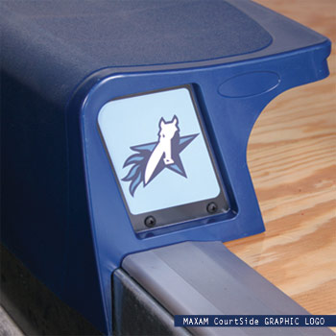
Courtside Graphic Logo

- Decorative graphic logo that is applied to the integrally molded end cap recess area of the CourtSide 10 XC or 12XCS seat module.
- Logo is approximately 4.7” (h) x 3.5” (w) w/full color CMYK vector art output on FujiFlex crystal archive printing material. (FujiFlex Specs. Available)
- Color logo is laminated with a 5-mil Hard Guard Matte laminate (Specs. Available)
- Laminated logo is bonded to a Flex-Con L – 606 laminating adhesive layer (Specs. Available)
- Logo is trimmed to a precise custom cut shape with two mounting holes

Courtside XT (Seat Spacer)
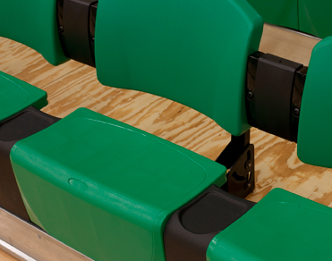
- Courtside XT Spacers are mounted between CourtSide XC10 or XCS12 seat modules
- Courtside XT Spacers provide additional 4-1/2” of clear space space between Courtside seats.
- CourtSide XT Spacers can be selected with an integral tray or 3” cupholder for enhanced spectator features.
- CourtSide XT Spacer Attachment: Each polymer spacer shall be securely anchored by a 12 ga steel clamp bracket that provides a steel-to-steel, through bolted attachment to the front nose beam of the bleacher. Attachment eliminates fore / aft movement of spacer on the nose beam.
- Unit structural tested to 600 lbs static load in the center of the XT top surface.

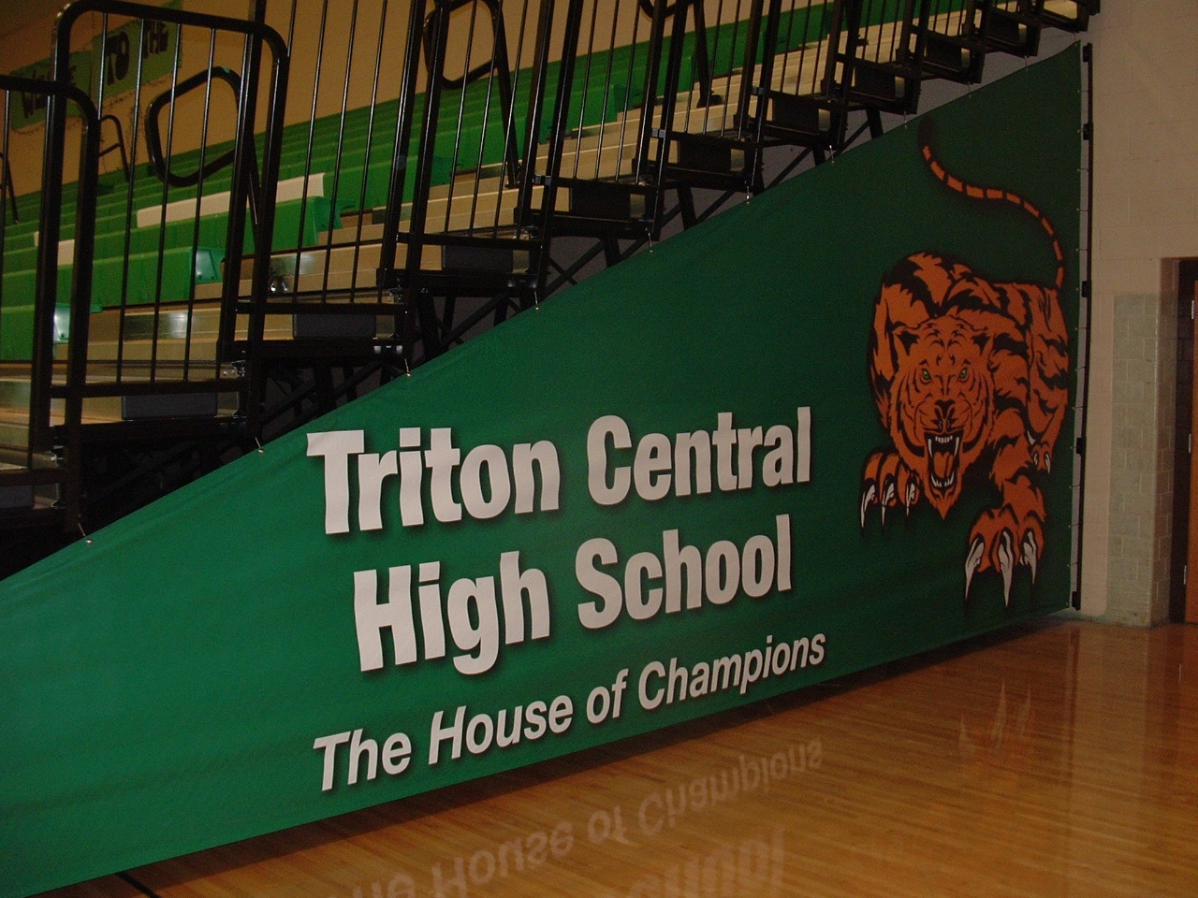
Full Bleed Graphic Vinyl End Closure Curtains
- Provide closure curtains fabricated of vinyl-coated 14oz Polyester fabric on open ends of telescopic seating. Curtains to be permanently attached to wall or rear closure panel and secured to individual rows of seating. Curtain to open with seating unit into taught secure configuration and fold automatically as seating unit closes.
- Curtain to have high resolution “full bleed” graphic logo or photograph located across entire visible surface area of the end curtain

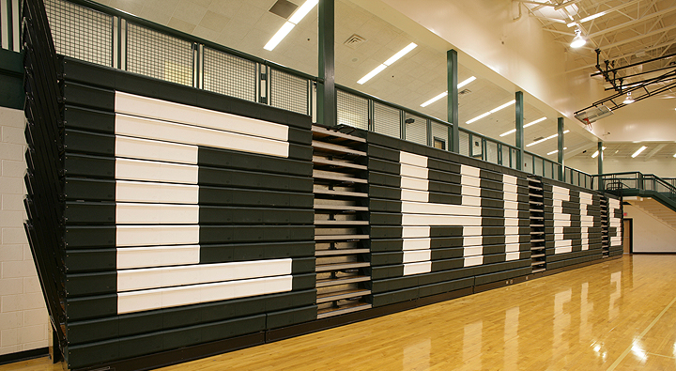
Custom Signature Logo
- Factory or Dealer designed logo that incorporates school letters or graphical representation of school logo across the front of the bleachers.
- Logo is visible when the bleachers are in the stored position.
- Select up to three colors for maximum color contrast and creativity.

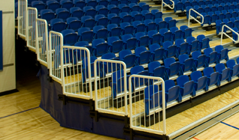

Colored Safety Rail Systems
- Choose from 15 Standard colors
- Durable powder coated finish.
- Add color on to Center Aisle Handrails, Self Storing or Removable End Rails or Front Rails

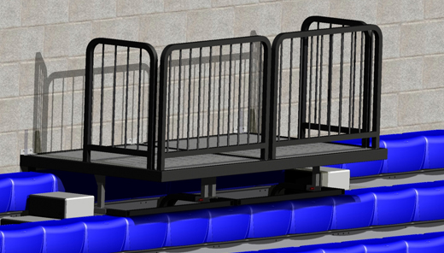
Portable or Semi Permanent Video Platforms
- Select Portable or Semi-Permanent Video Platform
  - Portable: 4’ x 4’ portable sections that can be located anywhere on the bleacher system. Portable sections can be ganged together to create larger video platform.
  - Semi-Permanent: 4’ x 4’ wall attached sections that remain in place while bleacher is in the stored position. Semi-Permanent sections can be ganged together to create larger video platform.
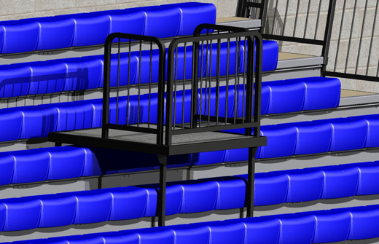
  - Portable video platforms come with options storage cart for easy transportation and setup.
  - Choose platform deck finish of UV clear coat or Panelam (polydeck) finish
  - Safety rails and steps (when required) are included

Extended 1st Row Team Seating
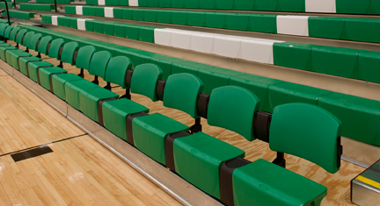
- Row 1(one) to be 30”, 32” or 33” row spacing for integrated seat and scorers seating
  - Courtside 10 XC or 12 XC plastic seat modules
  - Courtside Spacer modules to be located between each seat module
  - Each Courtside seat module to have accompanying Contoured Folding backrest
  - Choose platform deck finish of UV clear coat or Panelam (polydeck) finish

Gallery Beam Logo
- Decorative graphic logo to be located in recess on end stanchion assembly.
- Logo to match Courtside graphic logo in end caps of Courtside seats.
- Color logo is laminated with a 5-mil Hard Guard Matte laminate (Specs. Available)
- Laminated logo is bonded to a Flex-Con L – 606 laminating adhesive layer (Specs. Available)

PART 3 - EXECUTION

3.01 EXAMINATION

A. Verification of Conditions: Verify area to receive telescoping Platform seats are free of impediments interfering with installation and condition of installation substrates are acceptable to receive telescoping Platform seats in accordance with telescoping Platform seats manufacturer's recommendations. Do not commence installation until conditions are satisfactory.

3.02 INSTALLATION

A. Manufacturer's Recommendations: Comply with telescoping Platform seats manufacturer's recommendations for product installation requirements.

B. General: Install telescoping Platform seats in accordance with manufacturer's installation instructions and final shop drawings. Provide accessories, anchors, fasteners, inserts and other items for installation of telescoping Platform seats and for permanent attachment to adjoining construction.
3.03 ADJUSTMENT AND CLEANING

A. Adjustment: After installation completion, test and adjust each telescoping Platform seats assembly to operate in compliance with manufacturer's operations manual.

B. Cleaning: Clean installed telescoping Platform seats on both exposed and semi-exposed surfaces. Touch-up finishes to restore damage or soiled surfaces.

3.04 PROTECTION

A. General: Provide final protection and maintain conditions, in a manner acceptable to manufacturer and installer to ensure Telescoping Platform seats are without damage or deterioration at time of substantial completion.

END OF SECTION

